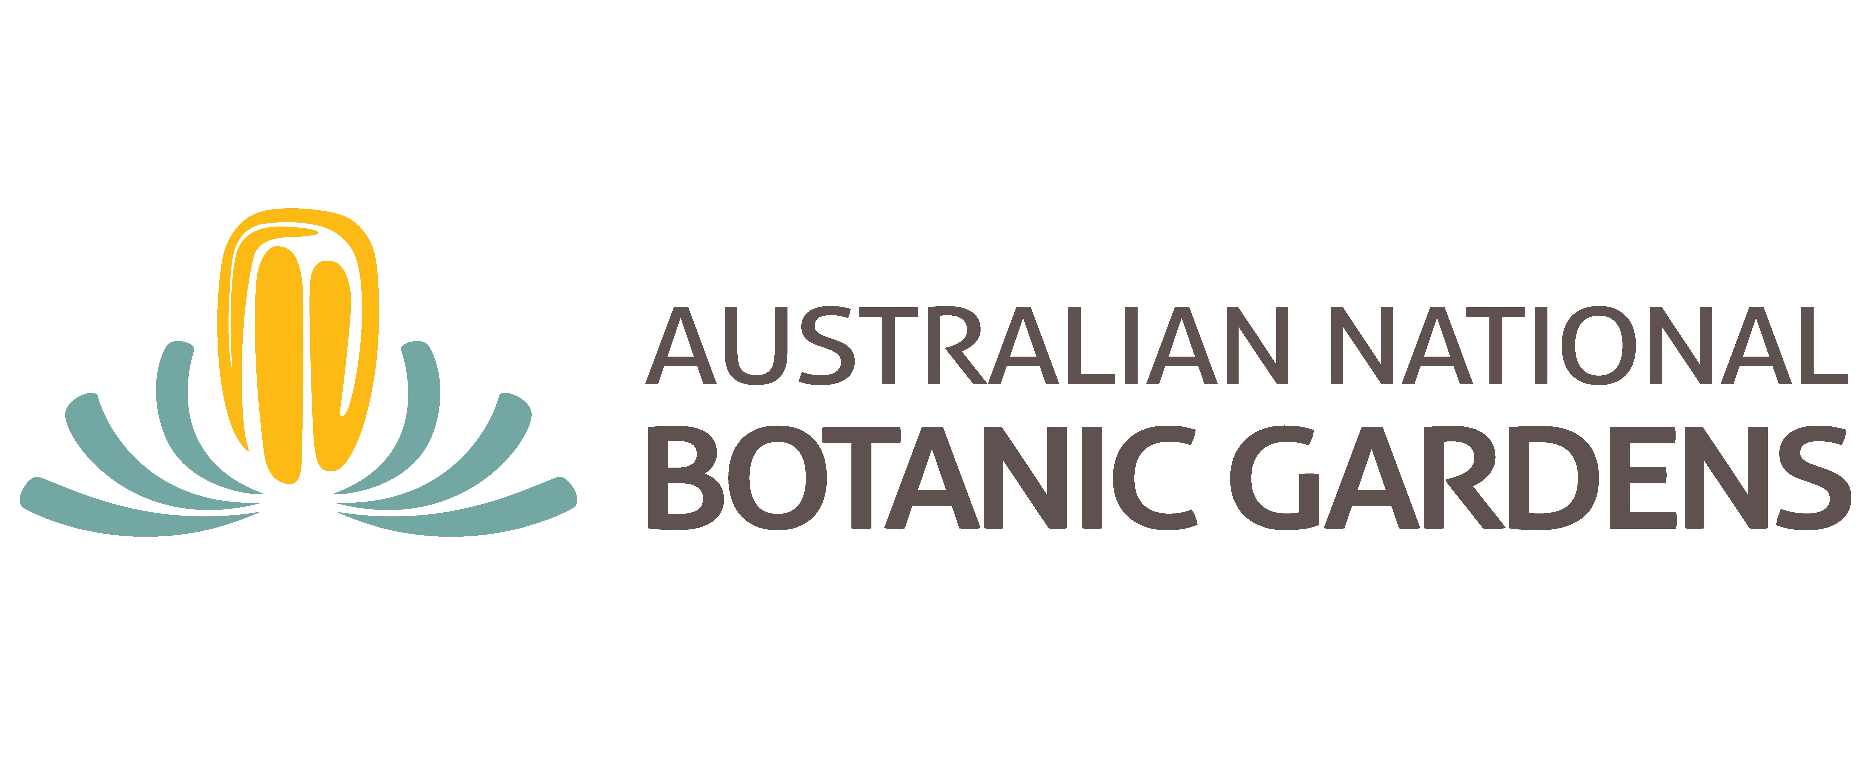

Donation Form

Personal Details

Title: Mr/Mrs/Ms/Dr or other………….
Name: _________________________________________________________________________

Postal Address:______________________________________________________Postcode _______

Email: _____________________________________________Ph __________________________

Acknowledgment (to be used in the Fronds magazine):

_________________________________________________________________________

Payment Details
Donation amount of $ _________________ by cash / cheque / credit card (please circle)

Credit card type: Mastercard / Visa (please circle)

Credit card number:

Cardholder name (block letters)____________________________________ Card Expiry date_______________

Cardholder signature________________________________________________________

Please make cheques payable to: The Australian National Botanic Gardens

Send cheques to: Partnership Development Manager, Australian National Botanic Gardens, GPO Box 1777 ACT 2601, or email this form with details to: adminstaff@anbg.gov.au

- Please send me information about leaving a bequest to the Australian National Botanic Gardens

All donations over $2.00 to the Australian National Botanic Gardens will receive a tax deductible receipt

Thank you for your donation to the Australian National Botanic Gardens

